**Bootstrap provides the following 3 form layouts**  
1. Vertical form (Default)  
2. Horizontal form  
3. Inline form  
  
**The followin are the classes that are used to style forms**  
form-group - Use this class on the <di

v> element that wraps labels and form controls for optimum spacing  
form-control - Use this class on all textual elements (<input>, <textarea>, and <select>)  
  
**Example :** In the HTML below we have 2 text boxes and a submit button

<form>

    <div>

        <label for="inputUserName">Username</label>

        <input type="text" id="inputUserName" />

    </div>

    <div>

        <label for="inputPassword">Password</label>

        <input type="password" id="inputPassword" />

    </div>

    <button type="submit">Login</button>

</form>

At the moment, we have not applied any of the Bootstrap form classes. If we view this page, in the browser this is how the form looks. Not very pretty.   
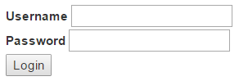  
  
**Creating a vertical form layout :** This is the default form layout. In the vertical form layout, the label and it's associated form control are stacked. Creating a vertical bootstrap form is very simple.  
1. Apply form-group class on the <div> element that wraps the label and the textbox  
2. Apply form-control class on the textbox   
  
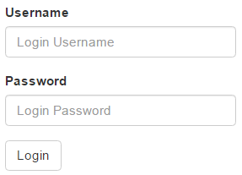

<form>

    <div class="form-group">

        <label for="inputUserName">Username</label>

        <input class="form-control" placeholder="Login Username"

                type="text" id="inputUserName" />

    </div>

    <div class="form-group">

        <label for="inputPassword">Password</label>

        <input class="form-control" placeholder="Login Password"

                type="password" id="inputPassword" />

    </div>

    <button type="submit" class="btn btn-default">Login</button>

</form>

**Creating an inline form layout :** Inline form layout places the form controls side by side. To create an inline form layout, all you have to do is apply form-inline class on the <form> element.   
  
bootstrap inline form example

<form class="form-inline">

    <div class="form-group">

        <label for="inputUserName">Username</label>

        <input class="form-control" placeholder="Login Username"

                type="text" id="inputUserName" />

    </div>

    <div class="form-group">

        <label for="inputPassword">Password</label>

        <input class="form-control" placeholder="Login Password"

                type="password" id="inputPassword" />

    </div>

    <button type="submit" class="btn btn-default">Login</button>

</form>

**Please note :** You get the inline form layout only if the viewport is at least 768px wide. If the viewport width falls below 768px, the form layout reverts to vertical.  
  
**Creating horizontal form layout :** In the horizontal form layout, the label is on the left and it's associated form control is on the right in a single line. To create a horizontal form layout  
1. Use the form-horizontal class on the <form> element  
2. Use the control-label class on the <label> element  
3. Use Bootstrap's grid classes to align labels and form controls   
  
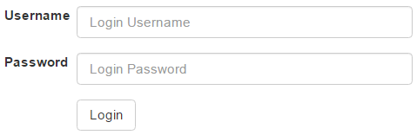

<form class="form-horizontal">

    <div class="form-group">

        <label for="inputUserName" class="control-label col-sm-2">Username</label>

        <div class="col-sm-10">

            <input class="form-control" placeholder="Login Username"

                    type="text" id="inputUserName" />

        </div>

    </div>

    <div class="form-group">

        <label for="inputPassword" class="control-label col-sm-2">Password</label>

        <div class="col-sm-10">

            <input class="form-control" placeholder="Login Password"

                    type="password" id="inputPassword" />

        </div>

    </div>

    <div class="form-group">

        <div class="col-sm-offset-2 col-sm-10">

            <button type="submit" class="btn btn-default">Login</button>

        </div>

    </div>

</form>

**Please note :** With this example, we will only have the horizontal form layout on a large, medium, and small screen sizes. On an extra small screen size, like a mobile phone, the form reverts to a vertical layout. If you want the horizontal layout on all screen sizes, including an extra small screen size, use col-xs-* grid classes instead of col-sm-* classes.